Python Lap Document

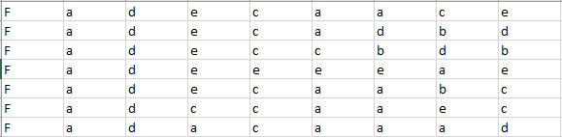Given file “StudentAnswers.csv” that contains answers of 50 students to 8 MCQ questions and the gender of each student. Data in file is as shown in figure1.

Student1

Q2 …..

Q1

Gender

Student2

Figure 1:File Data

Q8 …..

…..

The “pythonLap.py” file contains some code that you can start with. The code reads the data from the file, and has some necessary data to do the requirements like the correct answer for each question

## Requirements

1. Calculate number of students who didn't get the correct answer for the second question.

(Using **for loops** and **Vectorized Code)**

1. Calculate the average score of the students assuming that each correct answer gives 1 mark else 0. i.e. if student answered 8 questions correctly he gets 8/8. (Using **for loops** and **Vectorized Code**)
2. Create a bar plot for the number students who got the correct answer for each question.
3. Create pie plot for gender distribution of the students with labels.